**SSRS Lab - 5**

**Introduction**

Choose the Northwind database for this assignment.

**Creating a Database**

**Step 1: Open SSMS and Connect to a Data Engine**

1. Launch SQL Server Management Studio (SSMS).

2. Connect to the desired data engine by providing valid server credentials.

**Step 2: Restore Database**

1. Right-click on "Databases" in the Object Explorer.

2. Select the "Restore Database" option.

**Step 3: Restore Database from Device**

1. Choose the "Device" option.

2. Locate and move the locally stored database to the specified file path.

3. Select the database file and click "OK."

4. The file you have selected should appear here, click “OK”.

5. The added database should now appear in the "Databases" section.

**Building a Report**

**Step 4: Open the project .sln file from Lab - 1**

1. Follow the steps to create a new report.

**Step 5: Configure Data Sources**

1. Name your “Data source” and click "Edit" to configure the connection.

2. Specify the Server name.

3. Select the database you added in SSMS.

4. Click "OK" to save the data source.

**Step 6: Create Datasets and define Query**

1. Click on “Next” to open the query builder.

2. You can click on “query builder” and add the tables and columns or mention the query in the query string area.

This query is based on the report requirements.

3. Next, select the matrix report type

**Step 7: Completing the Wizard**

1. Click on “Next” until you see this page and rename the report name to “Customer_Sales_By_Years”.

2. You should see something like this

4. Go to expression on the order date and change it so it shows for a specific year

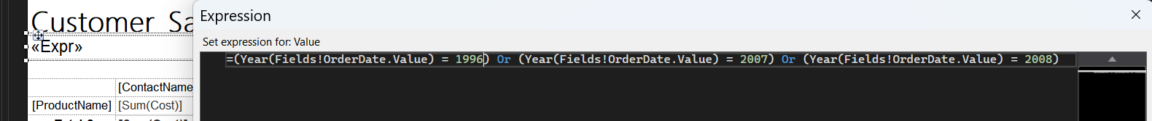

5. Create new row and new column called customer sum and product sum

**Step 8: Insert Rows/Columns**

1. To insert rows or columns, right-click on a cell, go to "Insert Row" or "Insert Column."

**Step 9: Beautify the Report**

1. Enhance the report's appearance by adjusting fonts, colors, and formatting, similar to Excel.

**Step 10: Finalize Report Design**

1. Once the report design is complete, save your work.

**Step 11: View your Report.**

1. Click the "Preview Report" button located in the top-left corner below the "File" menu.

2. Your report will be displayed with the data you configured.

You can go back to make changes by clicking on “Design”